103.39.94.24 kiet / hanbiro!@#$123 root / hanbiro!@#$123

**1. Recovery of dismiss employee**

**1) Dismiss your test account. -> on postmaster page**

Dismiss **kiet001** account

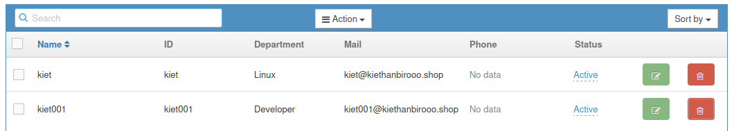

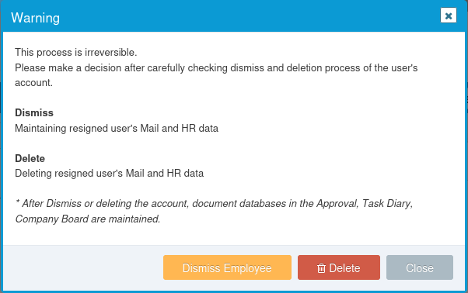

Transfer data to **kiet**:

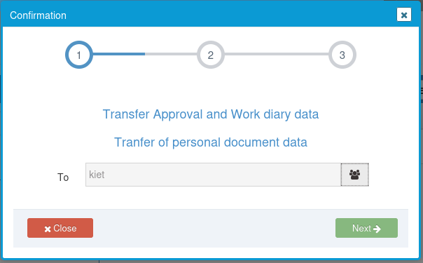

Forward mail to **kiet**:

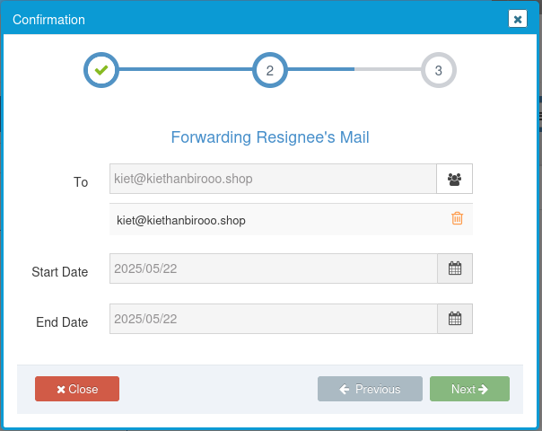

Sharing mail to **kiet**:

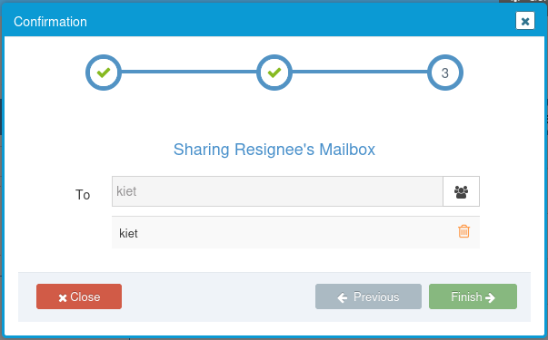

**kiet001** will be delete

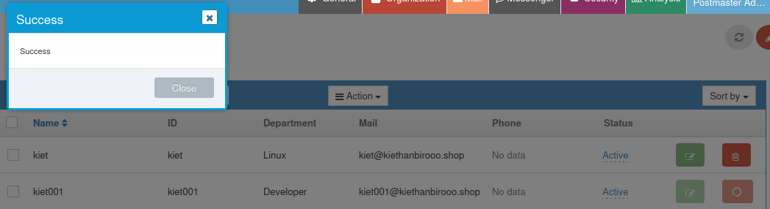

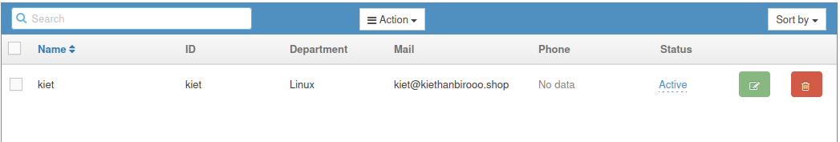

Login to **kiet001**:

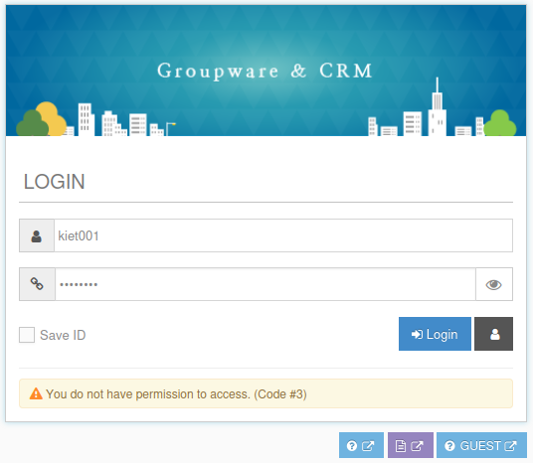

* add more user **kiethsoft**:

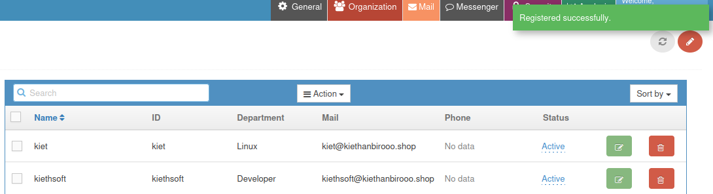

* test send mail from [**kiethsoft@kiethanbirooo.sho**](mailto:kiethsoft@kiethanbirooo.shop)**p** to [**kiet001@kiethanbirooo.shop**](mailto:kiet001@kiethanbirooo.shop) (mail will be move user kiet)

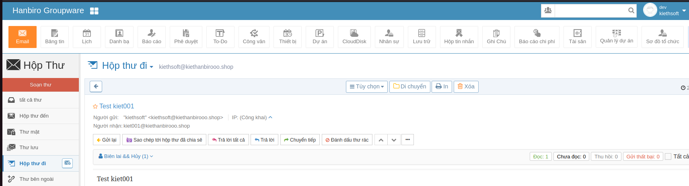

* check mail in user **kiet**

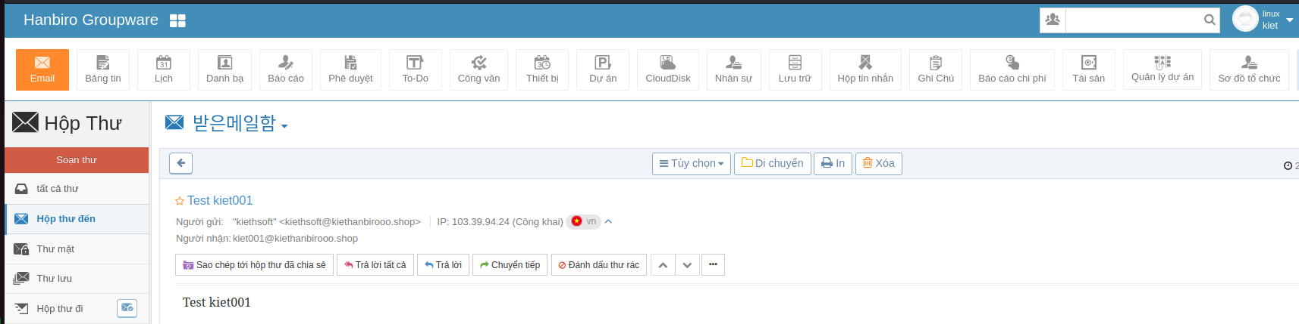

**2) Check the test account to see what has changed on the server.**

Check account in server:

* check user **kiet001**@kiethanbirooo.shop, but not found:

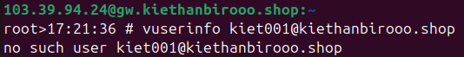

* check in **/home/vpopmail/domains/kiethanbirooo.shop/**



* recheck with **R_kiet001**@kiethanbirooo.shop, found user be dismissed:

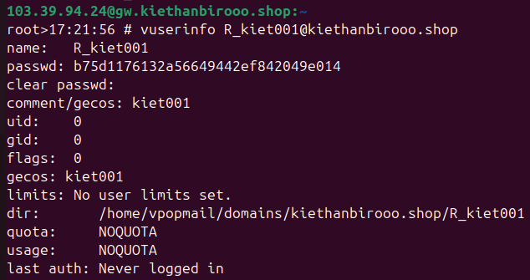

**3) Recover your test account using a script.**

ex) /root/Hanbiro/han/GW_script/

./recover_user.sh 'userid'’ domain’

**./recover_user.sh kiet001 kiethanbirooo.shop**

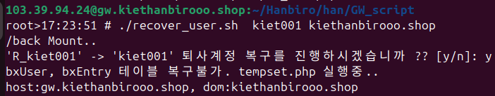

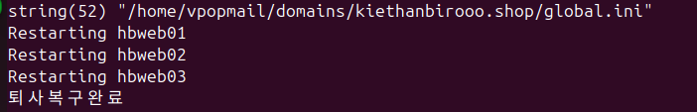

* check **vuserinfo kiet001@kiethanbirooo.shop**



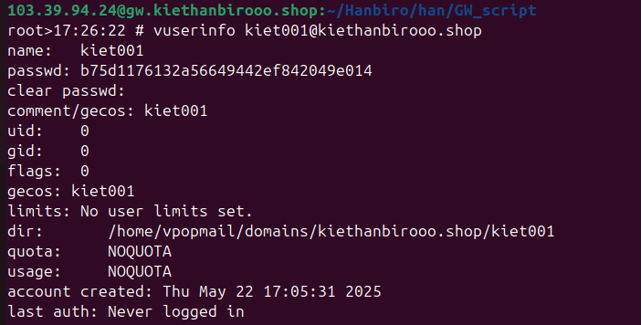

* But can not login with old password

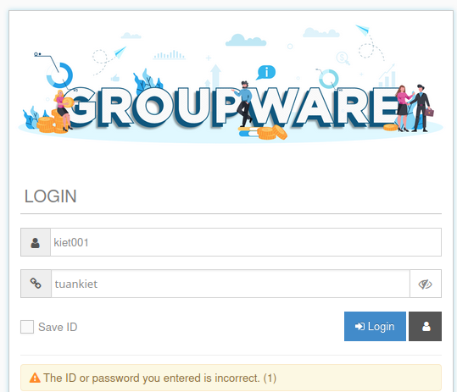

* Reset pass with postmaster account or vpasswd (passwd: tuankiet)



**4) After recover, log in to your account to check if there is any problem.**

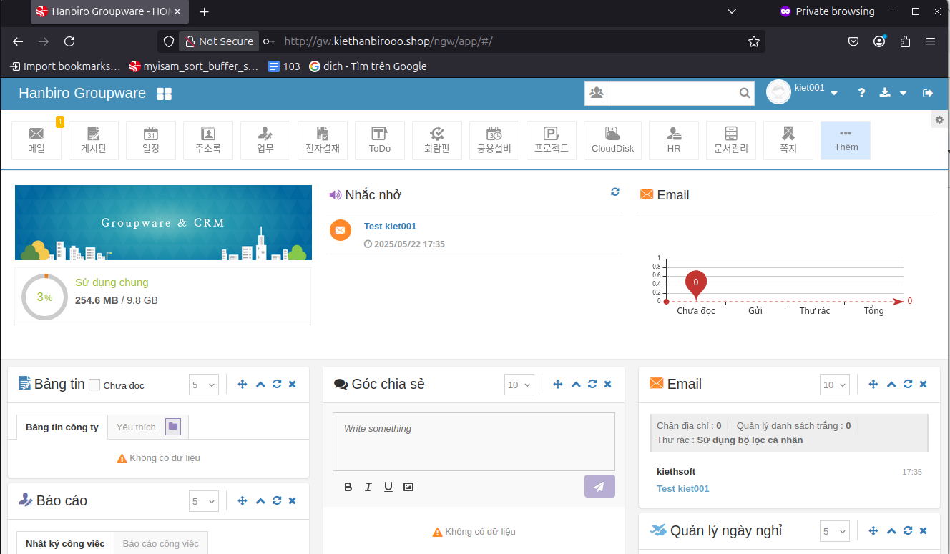

Account recovery successful

**5) Connect to an postmaster account and create new test account.**

Create new account test_recovery



**6) Delete the new test account you created and recover it.**





**test_recovery** will be delete successful

cd /root/Hanbiro/han/GW_script/

./recover_user.sh test_recovery kiethanbirooo.shop

Recovery account:

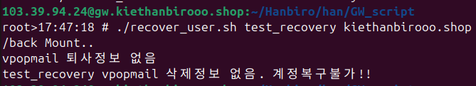

**7) If it does not recover, explain why.**

First check code **nano recover_user.sh**

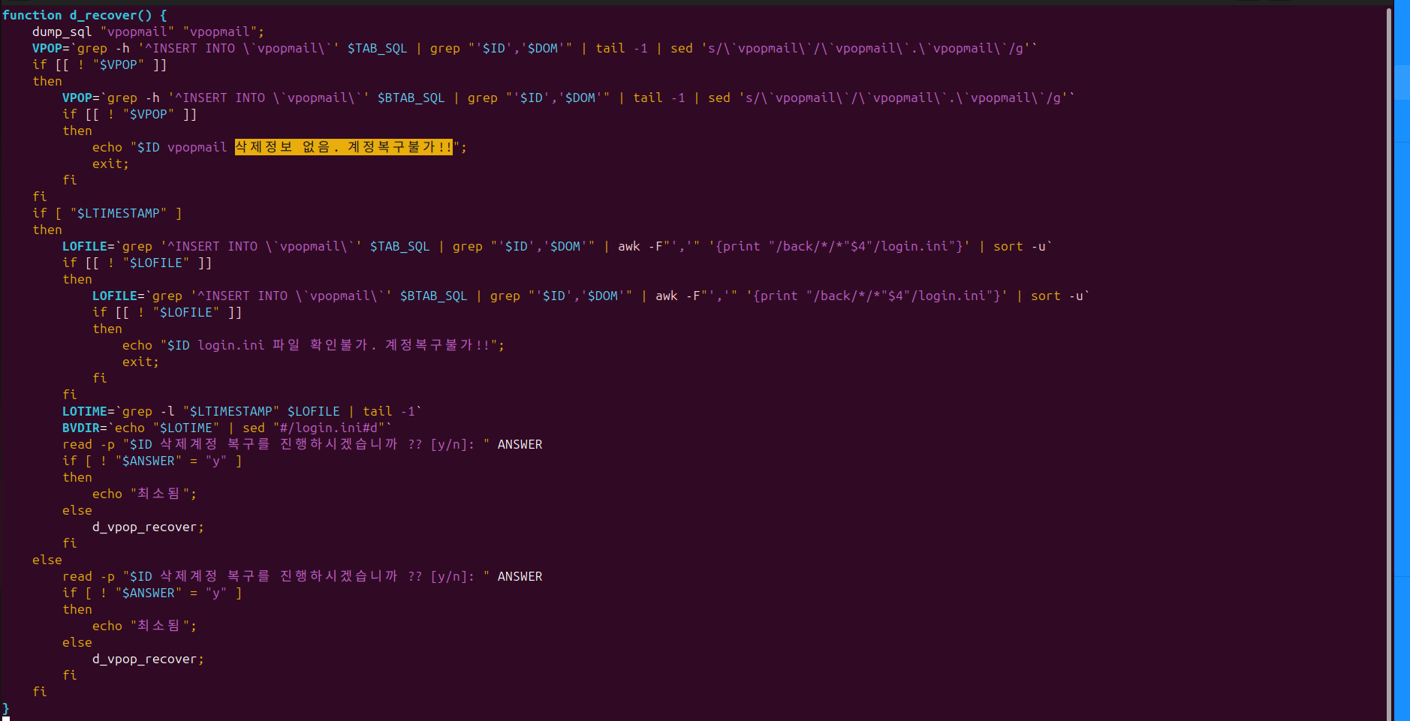

The account **test_recovery@kiethanbirooo.shop** could not be recovered because the script was unable to find any matching **INSERT INTO \`vpopmail`** statements in either the primary SQL dump file (**$TAB_SQL**) or its backup (**$BTAB_SQL`**). This indicates that the deleted user's data does not exist in the available backup files

Script:

VPOP=`grep -h '^INSERT INTO \`vpopmail\`' **$TAB_SQL** | grep "'$ID','$DOM'" | tail -1 | sed 's/\`vpopmail\`/\`vpopmail\`.\`vpopmail\`/g'`

and if it fails:

VPOP=`grep -h '^INSERT INTO \`vpopmail\`' **$BTAB_SQL** | grep "'$ID','$DOM'" | tail -1 | sed 's/\`vpopmail\`/\`vpopmail\`.\`vpopmail\`/g'`

As a result, the script outputs:

**test_recovery vpopmail 삭제정보 없음. 계정복구불가!!** (test_recovery vpopmail deletion information not found. Account recovery is impossible!!)

This means recovery is not possible unless a proper database dump containing the user's information exists and is accessible.

**2. Move Mail**

1) Connect to an postmaster account and create new test account. (**testmovemail**)



* check mail in **kiet**:

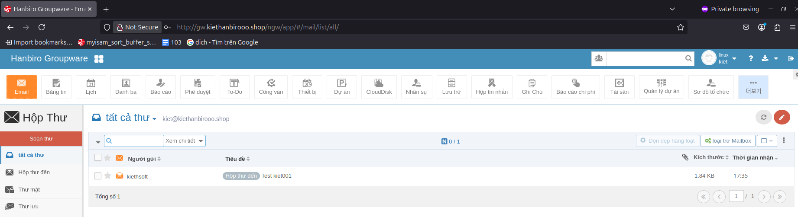

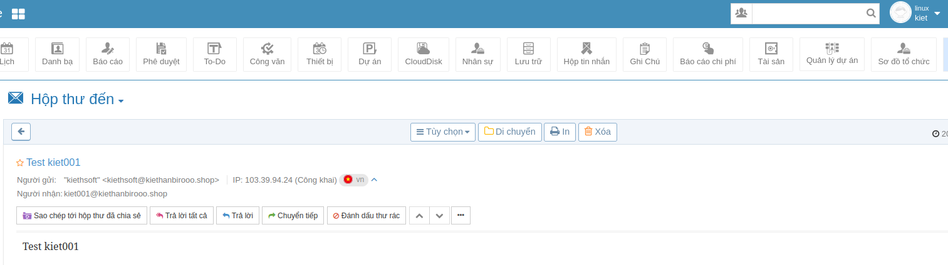

2) Use the script to move the mail from your test account to your new account.

ex) /root/Hanbiro/han/GW_script/

./mailcp.py 'source account' 'target account'

./mailcp.py [**kieth@kiethanbirooo.shop**](mailto:kiethsoft@kiethanbirooo.shop) [**testmovemail@kiethanbirooo.shop**](mailto:testmovemail@kiethanbirooo.shop)



3) Check where the moved mail was created.

Login to testmovemail and check folder share

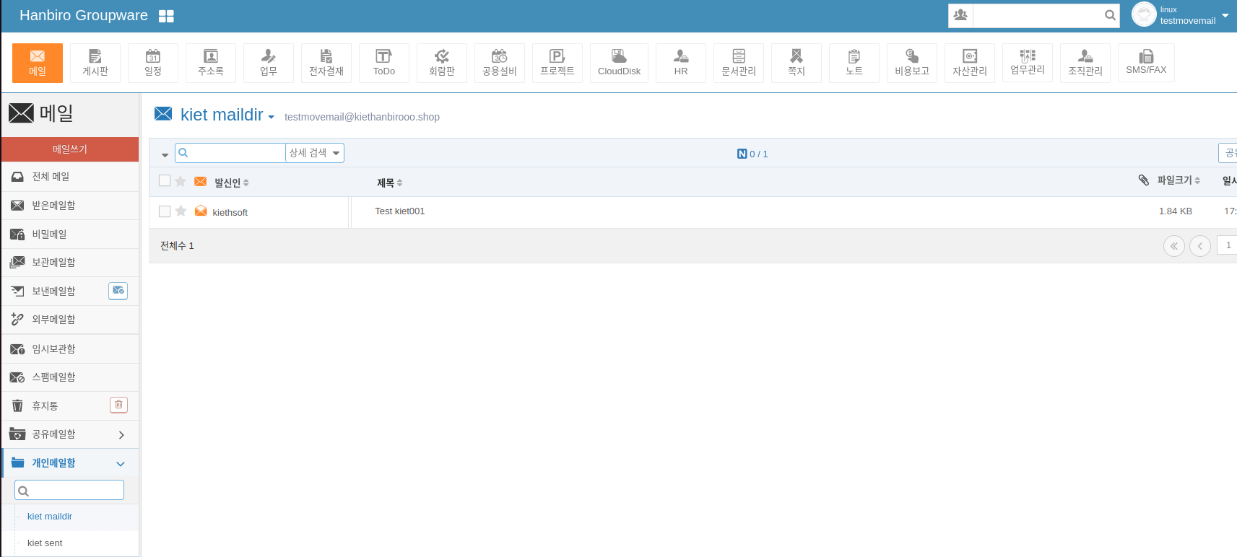

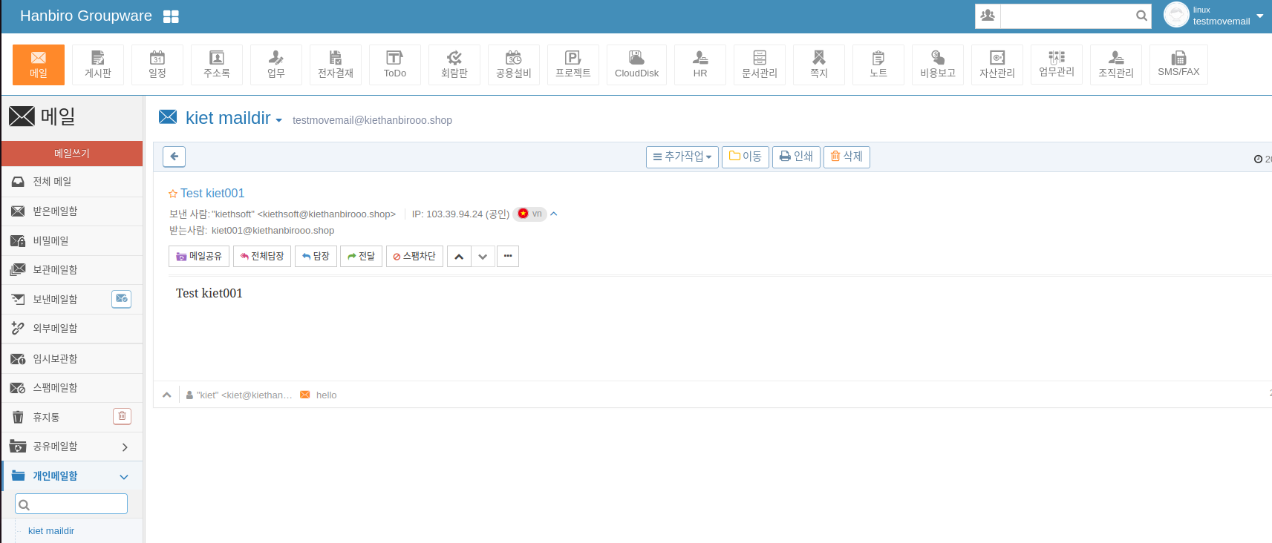

**3. Mail Backup Recovery**

1) Delete all mail in your test account.

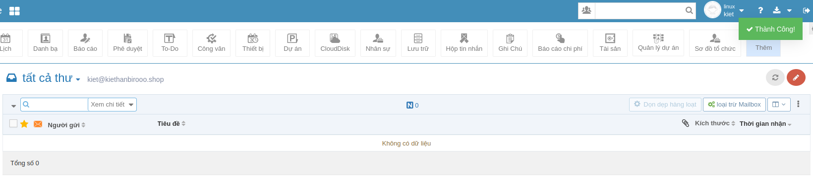

2) Check where the mail data backup is.

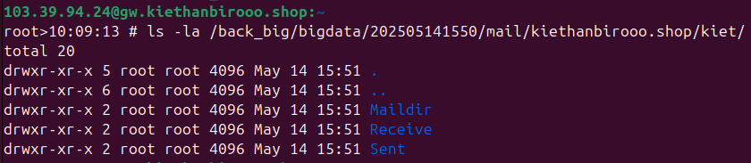

3) Use the script to recover the test account mail for .

ex) /root/Hanbiro/han/GW_script/

./var/HMAIL/Core/restoreuser.py 'userid' 'domain' 'mail backup path'

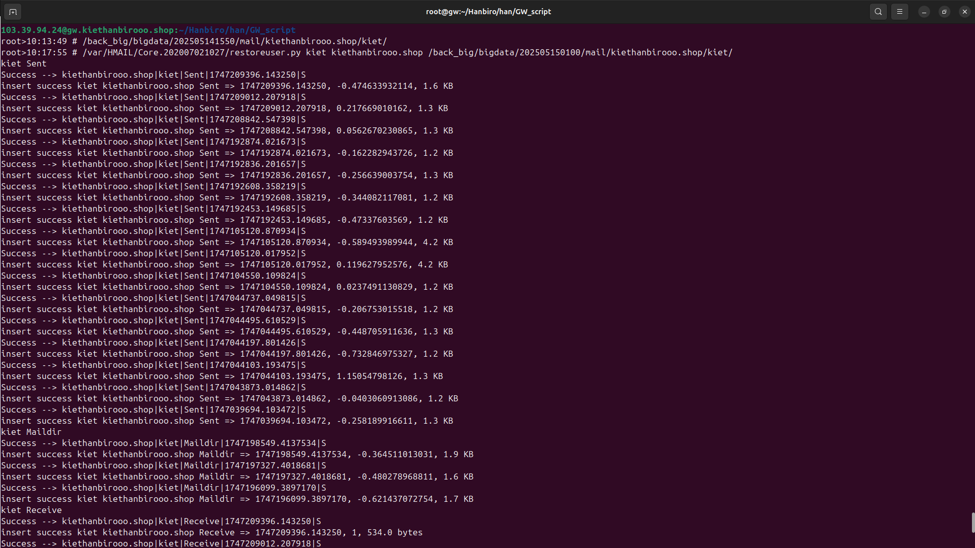

4) Verify that all mails have been recovered.

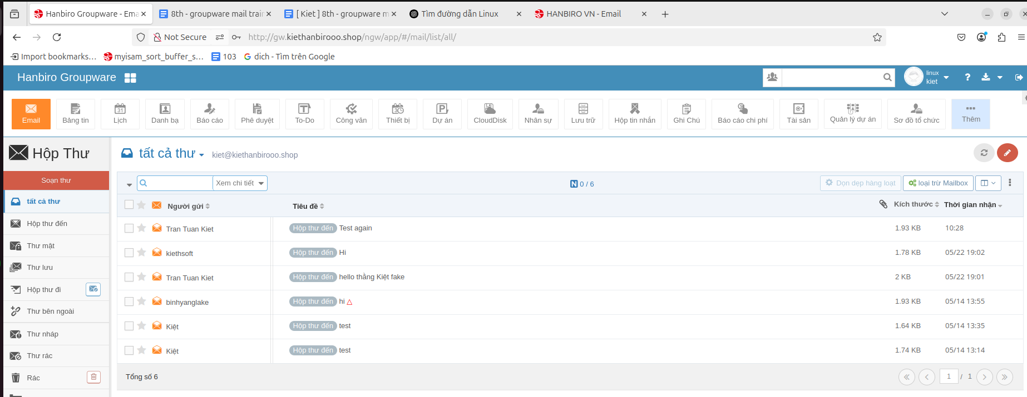

**4. Block Spam Mail**

Please proceed with this on your groupware test server.

- Block Domains

1) You are sending an email from your hanbiro mail to your test server account.

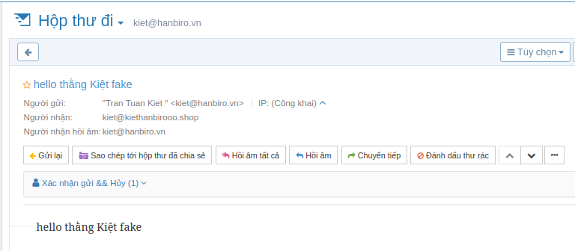

2) You confirm your mail receipt.

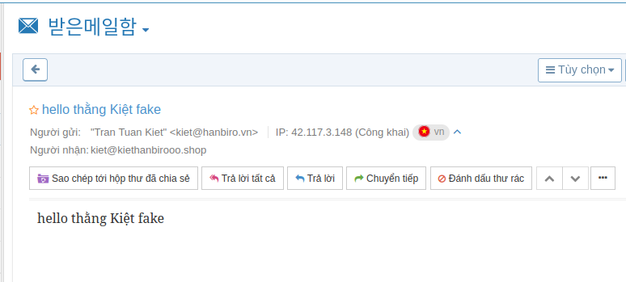

Check log:

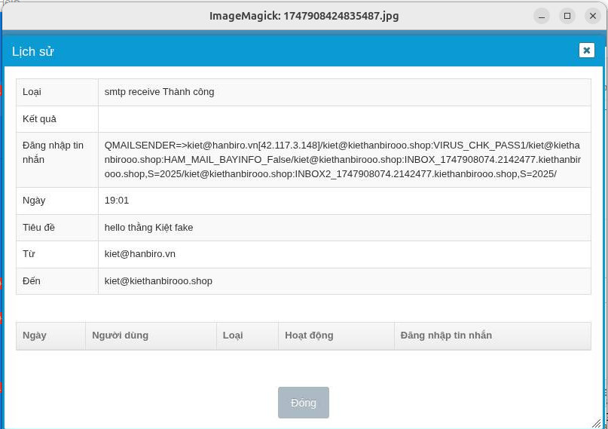

3) Create a bldns file to block hanbiro mail.

vi /home/vpopmail/domains/XXXXXXX/bldns

Enter the outgoing mail domain in the bldns file.

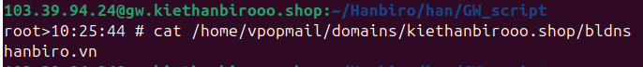

4) You are sending an email from your hanbiro mail to your test server account again.

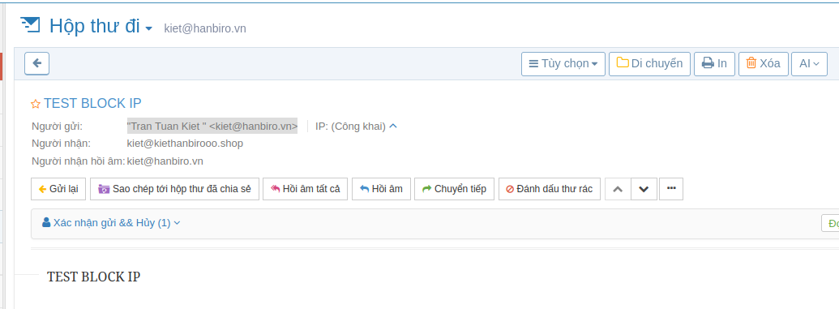

5) Check which logs are in the mail log.



Check Spam folder:

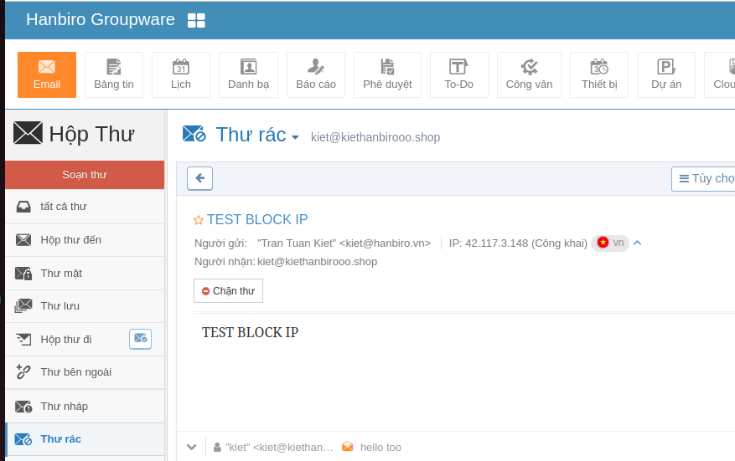

6) Delete the bldns file for the next training.

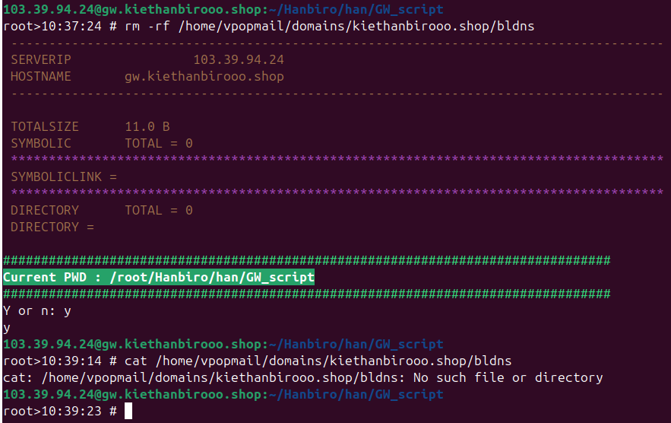

- Block IP

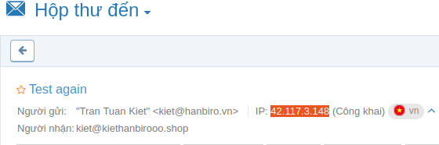

1) Create a blip file to block hanbiro mail.

vi /home/vpopmail/domains/XXXXXXX/blip

Enter the outgoing IP in the blip file.

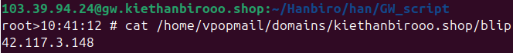

2) You are sending an email from your hanbiro mail to your test server account again.

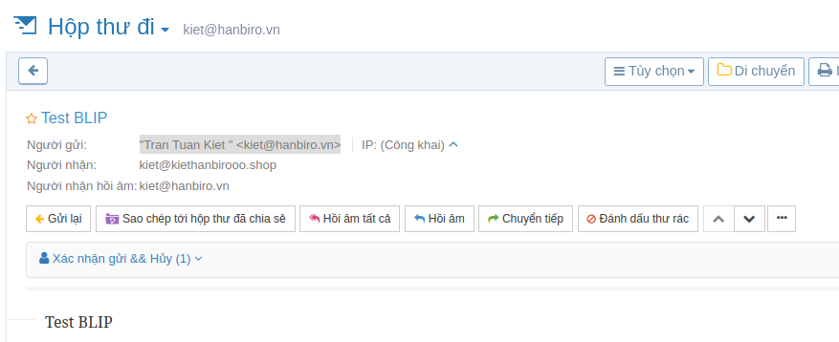

3) Check which logs are in the mail log.



4) Delete the blip file for the next training.

